WEEK 2 – DAY 2 ASSIGNMENT
Task 1: DOM to selenium code
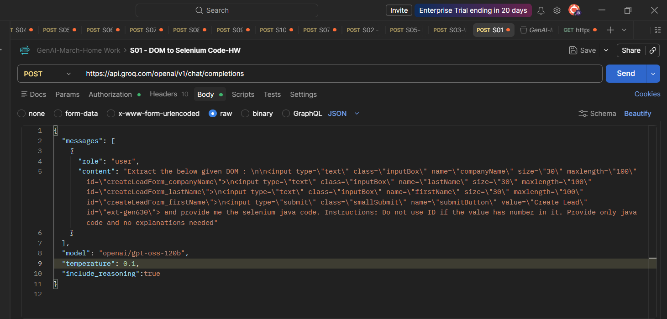

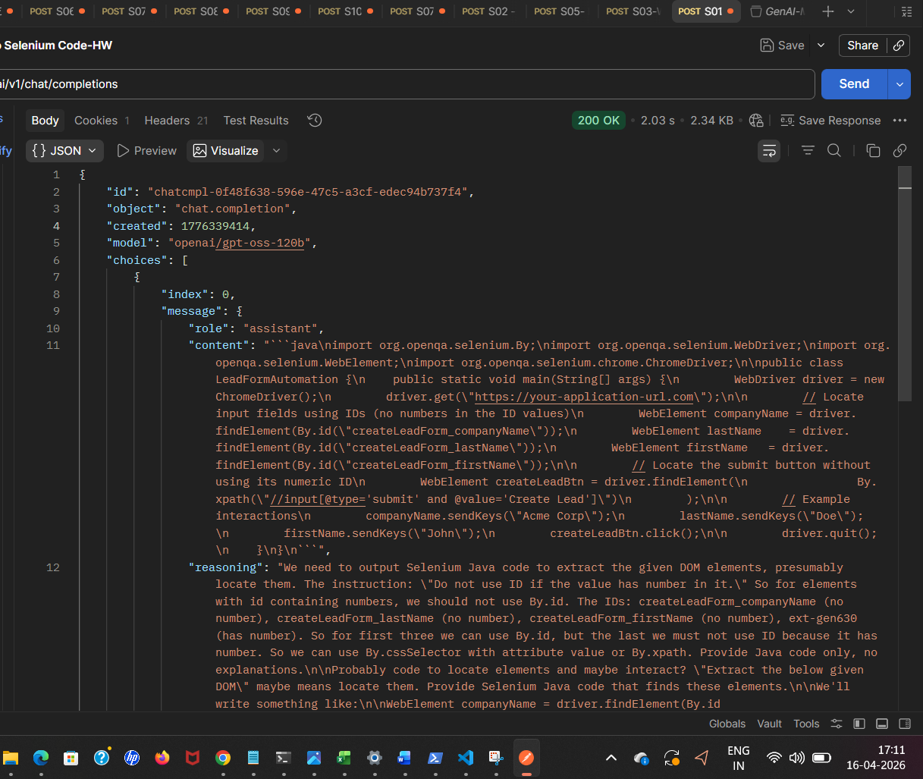

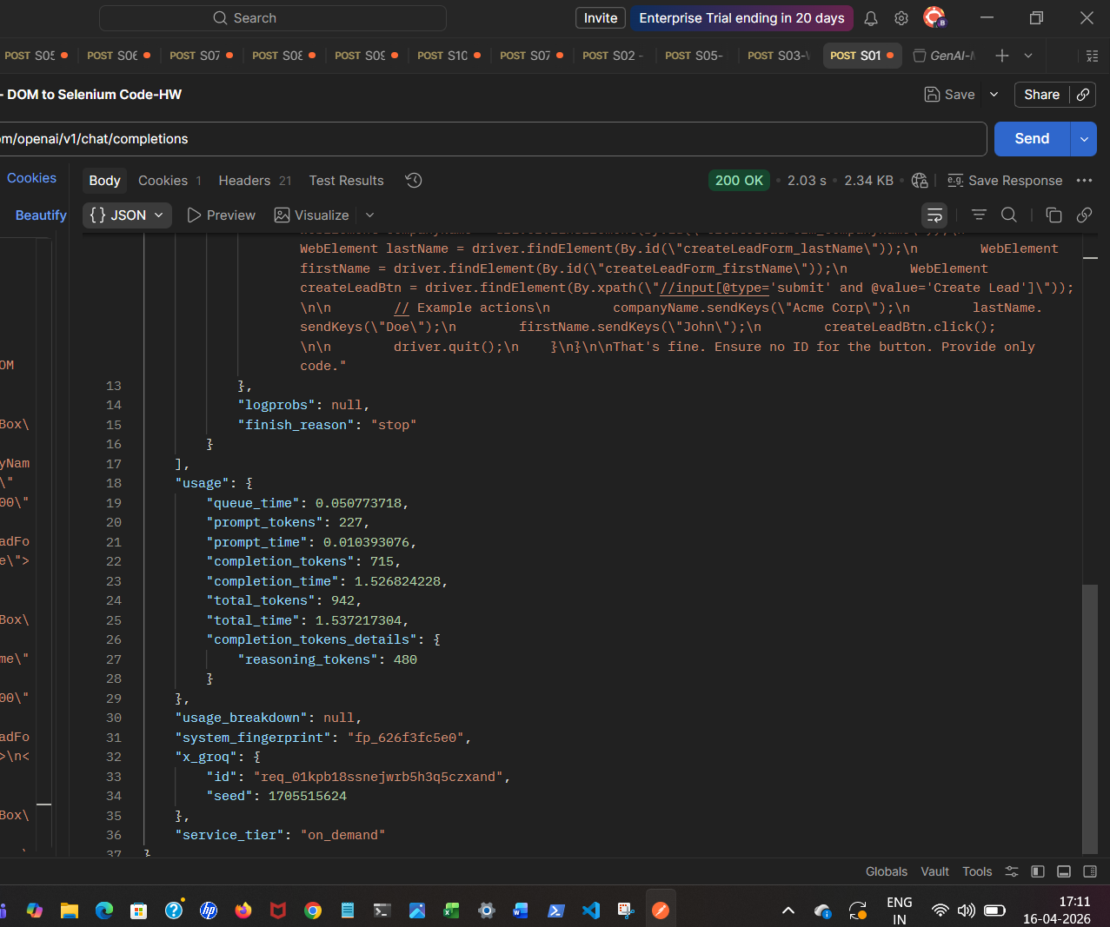

Task 2:
Image to Text search
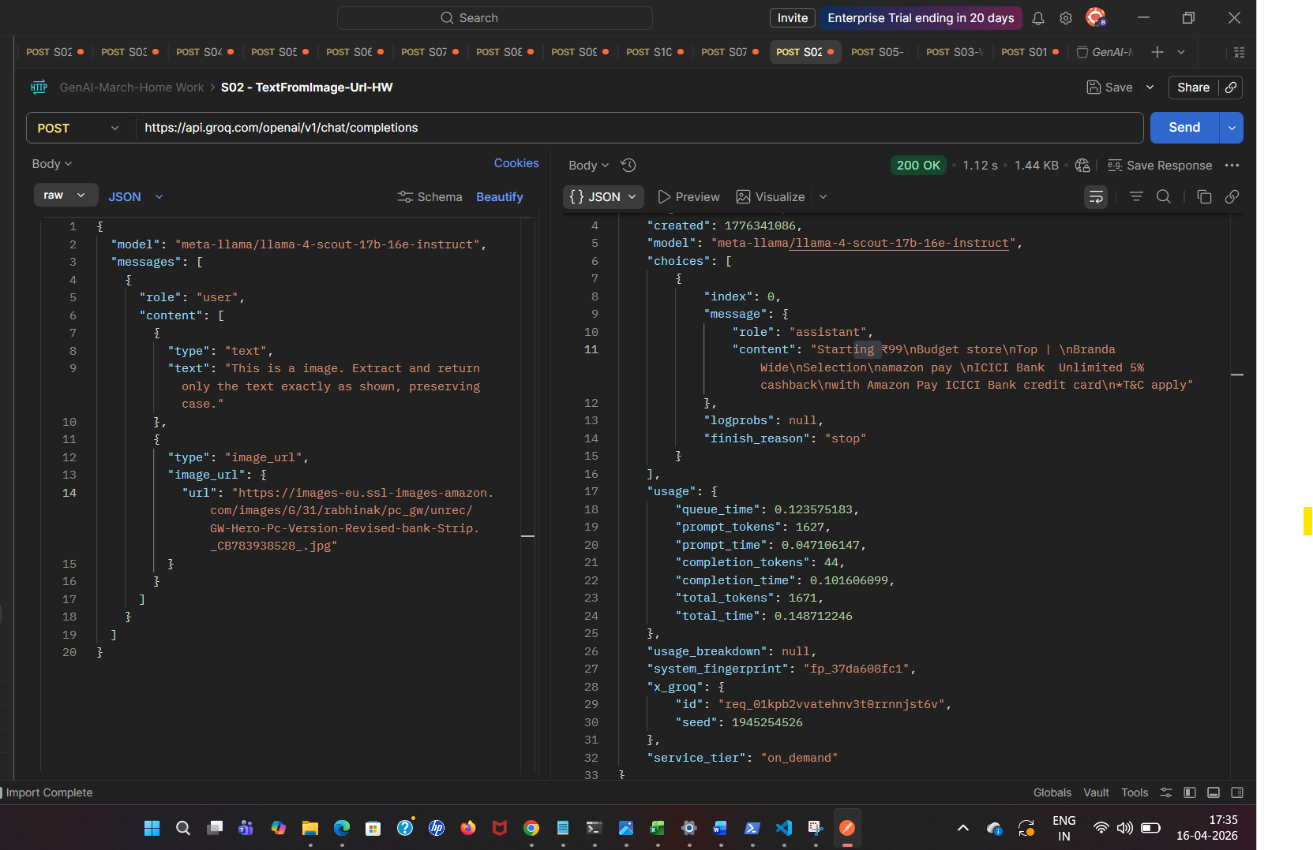

Task 3: Websearch
Request:
{
"model": "meta-llama/llama-4-scout-17b-16e-instruct",
"max_completion_tokens": 200,
"messages": [
{
"role": "user",
"content": "Explain me the need for ADA testing with WCAG standards, especially about 508 compliance. Limit with one search results"
}
]
}

Response:
{
"id": "stub",
"object": "chat.completion",
"created": 1776342503,
"model": "groq/compound-mini",
"choices": [
{
"index": 0,
"message": {
"role": "assistant",
"content": "## Accessibility Testing – The Big Picture \n\n| What it is | Why it matters | Typical activities |\n|------------|----------------|--------------------|\n| **Systematic evaluation of a product (web site, app, document, etc.) to see whether people with disabilities can use it** | Legal requirements (e.g., U.S. Section 508, EU’s EN 301 549), moral responsibility, better UX for everyone, SEO benefits | • Automated scans <br>• Manual keyboard-only checks <br>• Screen-reader walkthroughs <br>• Color-contrast inspection <br>• Real-user testing with people who have disabilities |\n| Goal: **Identify barriers** and produce a remediation plan that brings the product into conformance with an accessibility standard (most often the **WCAG**). |\n\n---\n\n## WCAG – Web Content Accessibility Guidelines \n\nWCAG is published by the **W3C’s Web Accessibility Initiative (WAI)**. The current version is **WCAG 2.2** (with a draft WCAG 3.0 on the horizon). \n\n### 1. Four Core Principles (POUR) \n\n| Principle | What it means | Example |\n|-----------|---------------|---------|\n| **Perceivable** | Users must be able to *perceive* information with any of their senses. | Provide alt text for images; supply captions for videos; ensure sufficient color contrast. |\n| **Operable** | Users must be able to *operate* the interface. | All functionality reachable via keyboard; avoid time-limits or give extensions; provide clear focus indicators. |\n| **Understandable** | Content and UI must be *understandable*. | Use simple language; consistent navigation; error messages that explain how to fix the problem. |\n| **Robust** | Content must work with current **and future** assistive technologies. | Use valid HTML; ARIA only when needed; avoid deprecated tags. |\n\n### 2. Success Criteria & Conformance Levels \n\nEach guideline is broken into **success criteria** that are testable statements. They are assigned a **level of impact**:\n\n| Level | Meaning |\n|------|----------|\n| **A** (lowest) | Must-have for basic accessibility; failure is a serious barrier. |\n| **AA** (mid) | The “reasonable” standard for most laws and policies (e.g., most Section 508 contracts, EU EN 301 549). |\n| **AAA** (highest) | The gold-standard; rarely required because many criteria are impractical for large sites. |\n\nA site can claim **WCAG 2.x Level AA conformance** when *all* Level A and Level AA success criteria are satisfied.\n\n### 3. How WCAG is Organized (WCAG 2.x)\n\n```\n1.1 Text Alternatives\n1.2 Time-Based Media\n1.3 Adaptable\n1.4 Distinguishable\n...\n2.1 Keyboard Accessible\n2.2 Enough Time\n2.3 Seizures\n2.4 Navigable\n...\n3.1 Readable\n3.2 Predictable\n3.3 Input Assistance\n...\n4.1 Compatible\n```\n\nEach numbered item is a **guideline**; underneath are the numbered success criteria (e.g., **1.1.1 Non-text Content**, **2.4.3 Focus Order**, **1.4.3 Contrast (Minimum)**).\n\n---\n\n## Section 508 – U.S. Federal Accessibility Law \n\n### What is Section 508? \n\n* **Statute**: Part of the Rehabilitation Act of 1973, amended in 1998 and refreshed in 2017 (the “508 Refresh”). \n* **Scope**: Requires all **federal agencies** (and any contractors/vendors that provide electronic & information technology—“EIT”) to make their ICT accessible to people with disabilities. \n* **Reference Standard**: The 2017 refresh aligns Section 508 with **WCAG 2.0 Level AA** (with a few additional, technology-specific requirements). \n\n### Key Points of the 2017 Refresh \n\n| Area | Section 508 requirement | WCAG equivalent |\n|------|------------------------|-----------------|\n| **Web pages & web apps** | Must conform to WCAG 2.0 AA | Same |\n| **Software** | Keyboard operable, text-based alternatives, color not sole means of conveying info | Mirrors WCAG 1.4.1-1.4.3, 2.1.1-2.1.2 |\n| **Multimedia** | Captions, audio description, transcript | WCAG 1.2.2-1.2.6 |\n| **Documents (PDF, Word, etc.)** | Must be accessible (tagged, readable by AT) | WCAG 1.1.1, 1.4.3, 2.4.4 |\n| **Hardware** | Controls operable without vision, tactile markings, etc. | Not covered by WCAG but analogous “operable” principle |\n\n> **Bottom line:** If you meet **WCAG 2.0 AA**, you are automatically in compliance with the federal Section 508 standard (unless you have a specific exemption).\n\n---\n\n## How to Perform Accessibility Testing \n\n### 1. **Automated Scanning (first pass)**\n- Tools: **axe**, **WAVE**, **Lighthouse**, **Pa11y**, **Siteimprove**, **Tenon**, **QualWeb**, etc. \n- What they catch: missing alt text, low contrast, ARIA misuse, form label issues, heading hierarchy errors. \n- **Limitations**: They can’t detect *all* problems (e.g., logical order, meaningful alt text, keyboard traps, focus management). Use them as a **triage** step, not the final verdict.\n\n### 2. **Keyboard-Only Testing**\n- Navigate the entire site using **Tab**, **Shift + Tab**, **Enter**, **Space**, arrow keys, and **Esc**. \n- Verify: \n - All interactive elements receive focus. \n - Focus order follows visual order. \n - No keyboard traps (you can always get out). \n - Visible focus indicator (default outline or custom style) meets contrast.\n\n### 3. **Screen-Reader Evaluation**\n- Choose a screen reader (NVDA, JAWS, VoiceOver, TalkBack). \n- Turn on the reader and explore the UI: \n - Does the page announce headings, landmarks, and form labels correctly? \n - Are ARIA roles/attributes used appropriately? \n - Are dynamic updates announced (e.g., live regions)? \n\n### 4. **Color-Contrast & Visual Checks**\n- Use a contrast analyzer (e.g., **axe Contrast**, **Color Contrast Analyzer**, **WCAG Contrast Checker**). \n- Minimum ratios: **4.5:1** for normal text, **3:1** for large text (WCAG 1.4.3). \n\n### 5. **Assistive-Technology Specific Tests**\n- **Zoom/Resize**: Ensure layout remains usable up to 200 % zoom. \n- **Voice Control**: Test with Windows Speech Recognition, Dragon, or macOS Voice Control. \n- **Alternative Input**: Switches, eye-tracking – usually covered by “operable” principle.\n\n### 6. **User Testing with People with Disabilities**\n- Recruit participants (screen reader users, motor-impaired users, low-vision users, cognitive-disability users). \n- Observe real-world tasks, collect qualitative feedback, and prioritize fixes that matter most.\n\n### 7. **Documentation & Reporting**\n- **Issue description** (what fails, where). \n- **WCAG success criterion** (e.g., 1.4.3 Contrast (Minimum) – AA). \n- **Severity** (critical, major, minor). \n- **Suggested remediation** (code snippet, design change). \n- **Verification steps** after fix.\n\n---\n\n## Quick “Starter Checklist” (WCAG 2.0 AA + Section 508)\n\n| Category | Must-have (WCAG A) | Must-have (WCAG AA) | Section 508 note |\n|----------|-------------------|--------------------|------------------|\n| **Text alternatives** | Alt text for *all* non-decorative images (1.1.1) | No audio-only content without transcript (1.2.4) | Same |\n| **Time-based media** | Captions for pre-recorded video (1.2.2) | Audio description for video (1.2.5) | Same |\n| **Adaptable** | Content can be presented in a single column (1.3.1) | Meaningful sequence (1.3.2) | Same |\n| **Distinguishable** | Contrast ≥ 4.5:1 (1.4.3) | Contrast ≥ 3:1 for large text (1.4.3) + non-text contrast (1.4.11) | Same |\n| **Keyboard** | All functionality operable via keyboard (2.1.1) | No keyboard trap (2.1.2) | Same |\n| **Enough time** | Adjustable time limits (2.2.1) | No timing unless essential (2.2.2) | Same |\n| **Seizures** | No content that flashes > 3 times/sec (2.3.1) | Same | Same |\n| **Navigable** | Clear focus order (2.4.3) | Headings & labels describe topic (2.4.6) + link purpose (2.4.4) | Same |\n| **Readable** | Language of page declared (3.1.1) | Language of passages declared (3.1.2) | Same |\n| **Predictable** | Consistent navigation (3.2.3) | No unexpected context changes (3.2.4) | Same |\n| **Input assistance** | Error identification (3.3.1) | Error suggestions (3.3.3) | Same |\n| **Robust** | Valid HTML, ARIA used correctly (4.1.1) | Same | Same |\n\n---\n\n## Common Pitfalls & How to Fix Them \n\n| Pitfall | Why it fails | Fix |\n|---------|--------------|-----|\n| **“Alt text = Image”** (e.g., `alt=\"image\"` ) | Does not convey meaning; WCAG 1.1.1 violation. | Write a concise description of the image’s purpose, or `alt=\"\"` for purely decorative images. |\n| **Insufficient contrast** (e.g., light gray on white) | Fails 1.4.3. | Increase contrast or add a darker outline/background. |\n| **Missing form labels** | Screen readers cannot announce purpose. | Use `<label for=\"id\">` or `aria-label`/`aria-labelledby`. |\n| **Keyboard trap** (modal that cannot be closed with Esc) | Violates 2.1.2. | Ensure all modals can be dismissed via keyboard and that focus returns to the invoking element. |\n| **Dynamic content not announced** (e.g., AJAX success message) | Users of AT miss updates. | Add `role=\"alert\"` or use an ARIA live region (`aria-live=\"polite\"`). |\n| **Improper heading hierarchy** (skip from H1 to H3) | Disorients navigation. | Keep a logical order: H1 → H2 → H3, etc. |\n| **Links with vague text** (“click here”) | Does not meet 2.4.4. | Use descriptive link text or provide `aria-label`. |\n\n---\n\n## Resources You Can Use Right Now \n\n| Resource | What it gives you | Free? |\n|----------|-------------------|-------|\n| **WCAG Quick Reference** (W3C) | Human-readable list of all criteria with techniques | ✔ |\n| **Section 508 Refresh – Standards** (U.S. Access Board) | Full legal text, mapping to WCAG | ✔ |\n| **axe DevTools** (browser extension) | Automated scans + guidance on fixing | ✔ |\n| **WAVE** (webaim.org) | Visual overlay of accessibility issues | ✔ |\n| **WebAIM Contrast Checker** | Quick contrast ratio calculator | ✔ |\n| **NVDA** (Windows) | Free screen reader for testing | ✔ |\n| **VoiceOver** (macOS/iOS) | Built-in screen reader | ✔ |\n| **Google Lighthouse** | Audits for WCAG 2.1 AA (and performance) | ✔ |\n| **Deque University** (free courses) | Introductory training videos | ✔ (some paid) |\n| **Accessibility Insights for Web** (Microsoft) | Fast automated + guided manual checks | ✔ |\n\n---\n\n## TL;DR Summary \n\n1. **Accessibility testing** = systematic checks (automated + manual) to ensure people with disabilities can perceive, operate, understand, and benefit from your product. \n2. **WCAG** is the global technical standard; it’s organized around the **POUR** principles and success criteria at Levels A, AA, and AAA. \n3. **Section 508** (U.S. federal law) now **mirrors WCAG 2.0 AA**, so achieving WCAG AA compliance usually satisfies the legal requirement for federal contracts. \n4. A solid testing workflow: \n - Run an automated scanner → fix obvious issues. \n - Perform keyboard-only navigation checks. \n - Test with a screen reader. \n - Verify color contrast and responsive scaling. \n - Conduct real-user testing with",
"reasoning": ""
},
"logprobs": null,
"finish_reason": "stop"
}
],
"usage": {
"queue_time": 0.212963,
"prompt_tokens": 468,
"prompt_time": 0.023163,
"completion_tokens": 3625,
"completion_time": 8.13945,
"total_tokens": 4093,
"total_time": 8.162613
},
"usage_breakdown": {
"models": [
{
"model": "llama-3.3-70b-versatile",
"usage": {
"queue_time": 0.161673578,
"prompt_tokens": 305,
"prompt_time": 0.016038155,
"completion_tokens": 625,
"completion_time": 1.747968251,
"total_tokens": 930,
"total_time": 1.764006406
}
},
{
"model": "openai/gpt-oss-120b",
"usage": {
"queue_time": 0.051289113,
"prompt_tokens": 163,
"prompt_time": 0.007125221,
"completion_tokens": 3000,
"completion_time": 6.391482147,
"total_tokens": 3163,
"total_time": 6.398607368,
"completion_tokens_details": {
"reasoning_tokens": 96
}
}
}
]
},
"x_groq": {
"id": "stub"
},
"service_tier": "on_demand"
}

Task 4:
Multi lingual
